1. **Introduction**
   1. Overview

The overview of analysing housing prices of metropolitan area of India under 6 major cities we analysed in this project. The places includes are Banglore, Chennai, Delhi, Kolkata, Mumbai and Hyderabad. Here we include the prediction models provides reliable insights and it gives a clear cut vision to the buyers.

* 1. Purpose

By Analysing housing prices in metropolitan areas of india the main purpose that it help the developer determine the selling price of a house and can help the customer to arrange the right time to purchase a house.

1. **Problem Definition and Design thinking** 
   1. Empathy map

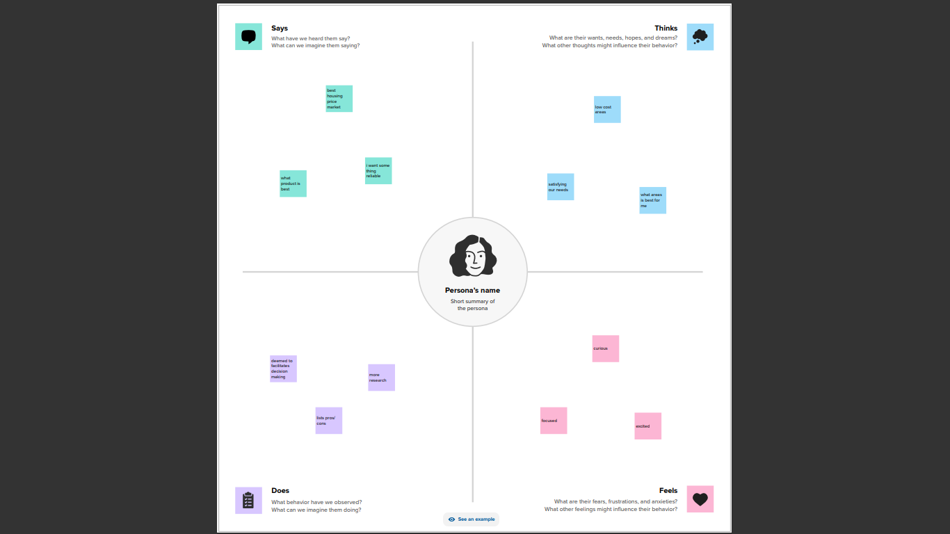

**2.2**Ideation and Brain stroming

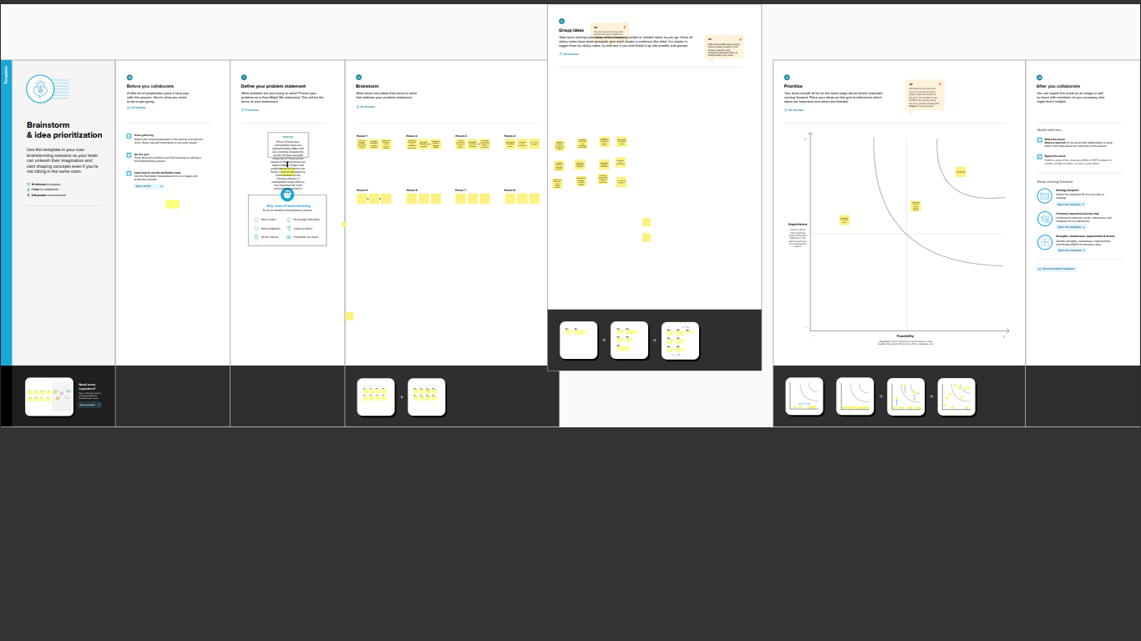

1. **Result**
2. **Advantages and disadvantages**

Advantages

Through this it will help to understand the current market prices of houses , how much similar properties are worth. If it is an instrument properly , how much you can change foe rent.

Dis advantages

It doesn’t predict the future prices of the houses mentioned by the customer. Due to this it is risk to investment on it because any time price value will change so it is the risk factor.

1. **Application**

The main application is it would be applied in various field to analyse the housing prices by customers. It gives a clear thinking to have houses in metropolitan areas of India

1. **Conclusion**

It analyse wheather the price holds in the housing market of six metropolitan areas in India. By the visualization process it helps to make the data easily understandable and the entire work and findings give more areas about the project.

1. **Future scope**

Changing demographics can impact house prices due to the age , income, and regional proferences of buyers.

Interest rates impact the demand and price for real – estate lower rates attract more hope with low mortgage rates but also expand demand which can drive up prices

Government policese and legislation, including tax incentive deduction and subsidues can boost are hinder demand for real estate.